Lab 10 Worksheet Karst and Deserts
Name ______ (-2 points if missing)
Date _______
Use your textbook, lab and lecture PowerPoints, and internet as needed to answer all questions in each of the 2 parts. Please explain everything in your own words.
Part 1 Karst Topography
Maps to use: Lake Wales, FL; Mammoth Cave, KY
General questions
- What rock type is prone to producing karst topography?

- Where are three places in the US prone to karst topography?

- In initial stages of karst development, what is the first feature to be visible at the surface?

- What karst features will develop at mid-stage of development?

- What karst features will develop at extreme late stage of development?

- How do solution valleys form?

- What museum had a sinkhole open under the floor, swallowing exhibit items?

Lake Wales, FL
- What are all those round depressions and lakes?

- If you were offered a home for a cheap price next to Lake Belle, would you buy it?

- What does the presence of so many lakes tell you about the water table?

- Why are some of these lakes strangely shaped?

- What is the stage of development seen in this map?

- Are there any disappearing streams in this map?

Mammoth Cave, KY
- What direction does Sinking Creek flow?

- What happens to Sinking Creek downstream?

- What type of stream is Sinking Stream?

- What stage of karst development is on this map?

- Identify at least 3 knobs on this map.

- Besides Mammoth Cave, name 3 other caves shown on this map.

Part 2 Desert
Maps to use: Ontario, CA
General questions
- What feature forms when multiple alluvial fans join together?

- What feature of deserts is shown in this image?

  - 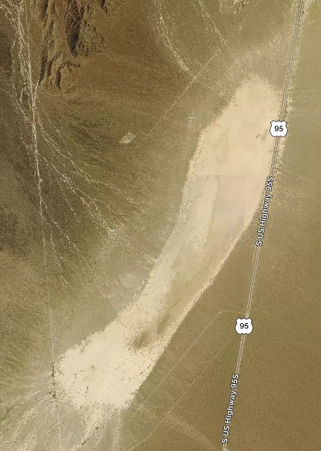

- Explain the difference between a plateau, mesa, and butte.

- What is a hoo doo?

- Identify at least 3 desert landforms in this image.
  - 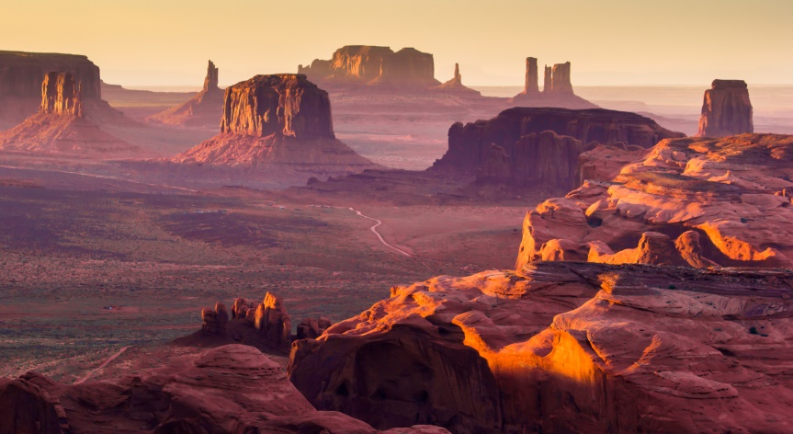

- Which are most common in the desert environment: gaining streams or losing streams (Hint: think back to Lab 11)?

- What direction is the wind from in this image?
  - 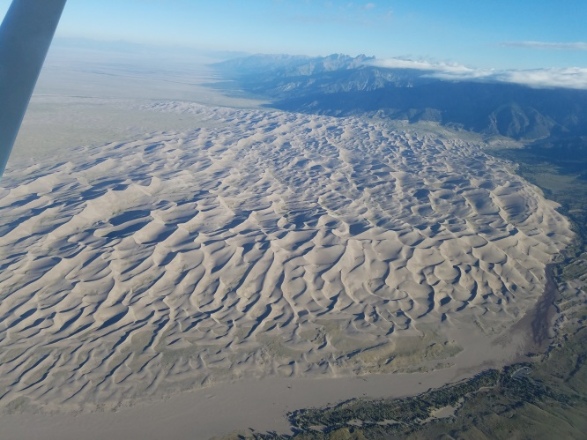

- What are the 5 major types of dunes?

- What is the name of the driest desert on Earth?

Ontario, CA
- What type of desert features in found south of the bright green area, coming out of the mountains? (Hint: observe the shapes of the contour lines)

- In previous maps, we saw intermittent streams turn into perennial streams. In this map, the perennial streams turn into intermittent streams. How would you explain this?

- Identify 3 streams that start perennial, and become intermittent.

